Exercise 3
The Alphabet and Pronunciation
Write out and pronounce the Greek letters of the alphabet several times. It is essential to learn how to recognize, write, and pronounce each letter. You cannot continue until you have done so.
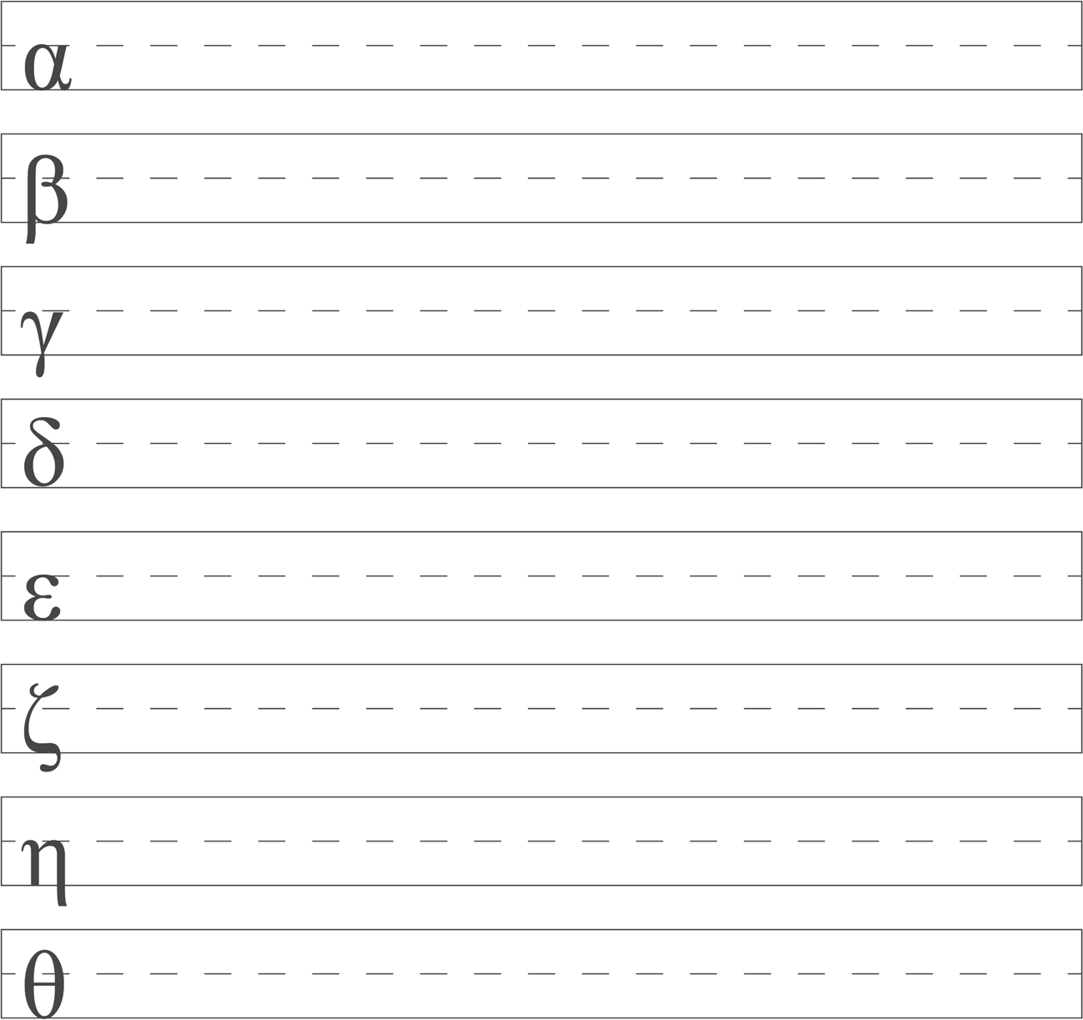
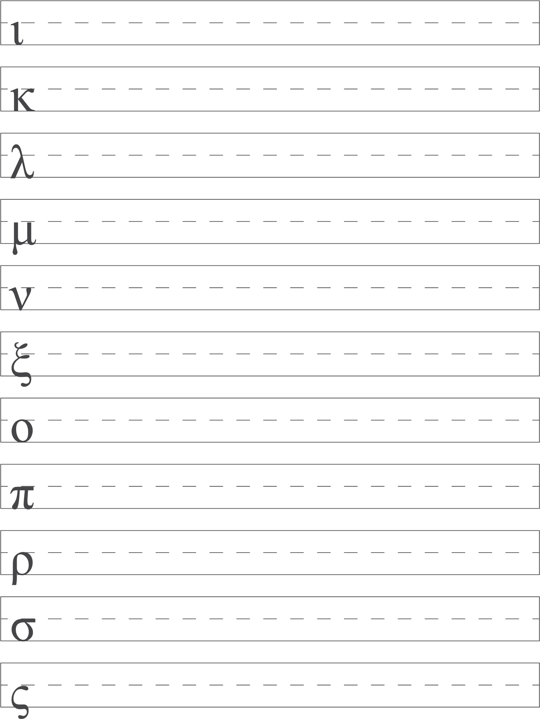
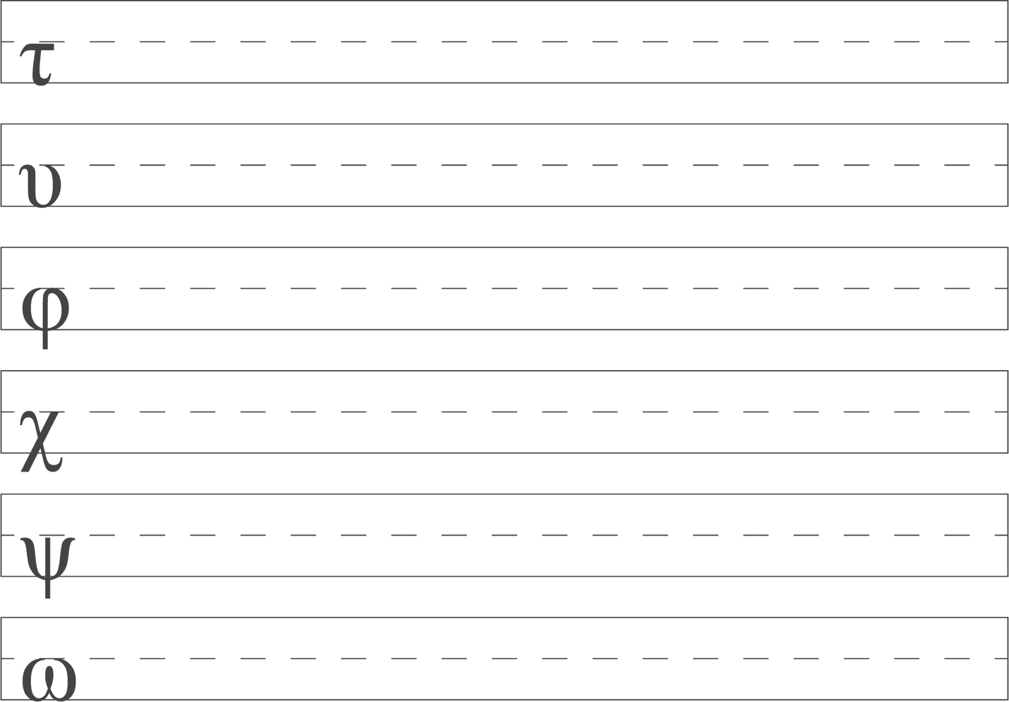
\
William D. Mounce, Basics of Biblical Greek Workbook, ed. Verlyn D. Verbrugge and Christopher A. Beetham, Fourth Edition (Grand Rapids, MI: Zondervan, 2019).
Page 3. Exported from Logos Bible Study, 8:27 PM July 21, 2026.

